An Expository Study Regarding Quantum Mechanical Thermodynamics

Rahul Panse

Table of Contents

Abstract 4

Introduction 5

1. Classical Thermodynamics and Statistical Mechanics 6

1.1 Mathematical Foundation of the Third Law 7

1.2 Energy and Entropy 9

1.3 Gibbs Entropy 10

1.3.1 The Interpretation of the Gibbs Formula 10

1.4 Helmholtz Free Energy and Gibbs Entropy 11

2. Foundations of Quantum Mechanics 12

2.1 The Postulates of Quantum Mechanics 12

2.2 Microcanonical, Canonical and Grand Canonical Ensembles 13

2.2.1 The Microcanonical Ensemble 13

2.2.2 The Canonical Ensemble 13

2.2.3 The Grand Canonical Ensemble 14

2.3 Density Operators and Mixed States 14

2.3.1 Pure and Mixed States 15

2.3.2 The Density Operator 16

2.4 von Neumann Entropy 17

2.4.1 Classical Entropy 17

2.4.2 Derivation via Spectral Decomposition 17

2.4.3 Properties of von Neumann Entropy 18

2.4.4 The von Neumann Entropy for the Excited He Atom 19

3. Bridging Classical and Quantum Thermodynamics 21

3.1 The Arrow of Time 22

3.2 The Lindblad Master Equation 23

3.3 Quantum Analogs of Classical Thermodynamic Quantities 27

3.3.1 Quantum Thermal States 28

3.3.2 The Derivation of the Gibbs Distribution 28

3.3.3 Properties of the Gibbs Quantum State 29

3.3.4 The Spectral Decomposition of the Gibbs State 29

3.4 Free Energy in Quantum Systems 30

4. Quantum Definitions of Work, Heat, and Energy 31

4.1 The Two-Point Measurement Scheme 31

4.1.1 The Joint Probabilities of the Eigenvalues 32

4.2 Work and Heat in Open Quantum Systems 33

4.3 Temperature in the Context of Quantum Thermodynamics 34

4.4 Energy in the Quantum Context 35

5. Quantum Entropy and Thermodynamic Potentials 37

5.1 A Comparison of Quantum and Classical Thermodynamic Entropies 37

5.2 The Thermodynamic Potentials 39

5.2.1 The Internal Energy Potential 39

5.2.2 The Legendre Transformation 40

5.2.3 The Enthalpy Potential 40

5.2.4 The Gibbs Enthalpy Potential 41

5.2.5 The Free Energy Potential 42

6. Quantum Resource Theories and the Second Law of Quantum Thermodynamics 42

6.1 The Second Law of Quantum Thermodynamics 43

6.1.1 The Second Law from a Resource-Theoretic Perspective 44

6.2 Quantum Resource Theories (QRT) 45

6.2.1 The Entanglement Resource Theory 46

6.2.2 Asymmetry and Quantum Reference Frames 47

6.2.3 Thermodynamic Non-Equilibrium as a Quantum Resource 48

6.2.4 Energy-Incoherent States and Thermo-majorization in the Context of Athermality 50

6.2.5 The Thermo-Majorization Curve 51

6.2.6 The Coherence Resource Theory 52

7. Quantum Fluctuation Theory in Nonequilibrium Thermodynamics 53

7.1 Introduction to Quantum Fluctuation Theorems 53

7.2 The Quantum Jarzynski Equality 54

7.3 The Quantum Crooks Theorem 56

7.3.1 Preliminary Framework and Underlying Assumptions 56

7.3.2 The Derivation of the Crooks Theorem 57

7.4 Entropy Production and Time-Reversal Symmetry 59

7.4.1 The Quantum Integral Fluctuation Theorem 59

7.5 Measurement Backaction and Irreversibility 63

7.6 Conclusion 64

8. Quantum Heat Engines 64

8.1 The Quantum Carnot Engine 65

8.1.1 Isothermal Expansion under Hot Bath Conditions 66

8.1.2 The Adiabatic Expansion 66

8.1.3 Isothermal Compression under Cold Bath Conditions 66

8.1.4 The Adiabatic Compression 67

8.2 The Quantum Otto Engine 67

8.2.1 The Adiabatic Compression 67

8.2.2 Isochoric Heating under Heat Bath Conditions 68

8.2.3 The Adiabatic Expansion 68

8.2.4 Isochoric Cooling under Cold Bath Conditions 69

8.3 The Impact of Coherence and Entanglement on Quantum Heat Engines 69

9. Thermodynamic Consistency of Quantum Master Equations 71

10. Information-Theoretic Approaches 72

10.1 Landauer’s Principle in the Quantum Domain. 72

10.1.1 Preliminary Framework and Assumptions 72

10.1.2 The Formal Derivation of the Landauer Principle 73

10.2 The Paradox of Maxwell’s Demon and Feedback Control 74

11. Outlook and Future Directions 75

Conclusion 76

References 77

# Abstract

This paper presents a comprehensive exposition of quantum thermodynamics, aiming to bridge the foundational concepts of classical thermodynamics and quantum mechanics. Beginning with a rigorous overview of classical thermodynamic laws and statistical ensembles, the work transitions into the quantum domain by introducing quantum states, density operators, and von Neumann entropy. Core thermodynamic quantities such as work, heat, energy, and entropy are redefined in the quantum regime, with emphasis on operational frameworks like the two-point measurement scheme. The study explores the role of quantum resource theories in formulating generalizations of the second law and delves into the intricacies of nonequilibrium thermodynamics through fluctuation theorems, such as the Jarzynski equality and Crooks theorem. Special attention is given to the influence of coherence, entanglement, and measurement backaction, which contribute uniquely to quantum thermodynamic behavior. The treatise concludes with a discussion on quantum heat engines, thermodynamic consistency of quantum master equations, and information-theoretic approaches, establishing quantum thermodynamics as a vital framework for understanding energy and information flow at the quantum scale.

# Introduction

Thermodynamics has long served as a cornerstone of physical theory, governing the macroscopic behavior of matter and energy through its immutable laws. However, as we delve into the microscopic domain, classical thermodynamic principles encounter limitations that necessitate reformulation within the framework of quantum mechanics. Quantum thermodynamics emerges as a natural synthesis of these two paradigms, aiming to reconcile thermodynamic behavior with the probabilistic and non-deterministic nature of quantum systems.

This paper embarks on an expository journey to construct a consistent and mathematically grounded theory of quantum thermodynamics. We begin by reviewing the classical laws of thermodynamics and their statistical mechanical interpretations, including concepts such as entropy, free energy, and equilibrium ensembles. From there, we transition into quantum mechanics, introducing the postulates of the theory, the formalism of density operators, and the von Neumann entropy, which serves as a quantum analog of classical entropy measures.

Bridging classical and quantum descriptions, we examine quantum analogs of thermal states, thermodynamic potentials, and the fundamental quantities of work and heat under various quantum protocols. The study advances to incorporate modern developments such as quantum resource theories, fluctuation theorems, and quantum heat engines—each contributing to our understanding of irreversibility, coherence, and energy manipulation in the quantum realm.

By drawing from both foundational principles and recent theoretical advances, this exposition aims to provide a clear, self-contained account of the subject, suitable for readers seeking to understand or research the emerging field of quantum thermodynamics.

# 1. Classical Thermodynamics and Statistical Mechanics

Classical thermodynamics governs the laws of thermodynamics in the classical world. Classical thermodynamics provides rigorous laws that simply cannot be broken down. Should the laws of thermodynamics break down, the behavior of the universe will become idiosyncratic, paradoxical, and simply make no sense. Therefore, classical thermodynamics provides a set of laws that are as follows,

(a) The Zeroth Law of Thermodynamics: If two systems are in thermodynamic equilibrium with a third system, the two original systems are in thermal equilibrium with each other.

(b) The First Law of Thermodynamics: It states that energy can be converted from one form to another with the interaction of heat, work and internal energy, but it cannot be created nor destroyed, under any circumstances.

(c) The Second Law of Thermodynamics: The state of entropy of the entire universe, as an isolated system, will always increase over time. The second law also states that the changes in the entropy in the universe can never be negative.

(d) The 3rd law of thermodynamics will essentially allow us to quantify the absolute amplitude of entropies. It says that when we are considering a totally perfect (100% pure) crystalline structure, at absolute zero (0 Kelvin), it will have no entropy. Note that if the structure in question were not totally crystalline, then although it would only have an extremely small disorder (entropy) in space, we could not precisely say it had no entropy.

## 1.1 Mathematical Foundation of the Third Law

I will now derive the mathematical representation of the third law. It is of the form,

Where, S(T) is the entropy at temperature T, T is in Kelvin.

We will derive the expression using the integrated form of the definition of entropy,

Where, is the heat capacity as a function of temperature, S(0) is the entropy at 0K.

We will have to assume

i) We are working with a perfect crystal.

ii) At absolute zero, all atoms are in their lowest energy state **→ only one microstate** ⇒ S(0) = = 0.

iii) The heat capacity C(T) for a solid at low temperatures follows **Debye’s Law,**

Therefore,

Where, a is a constant. We will now substitute this in the integral,

We obtain,

This clearly satisfies,

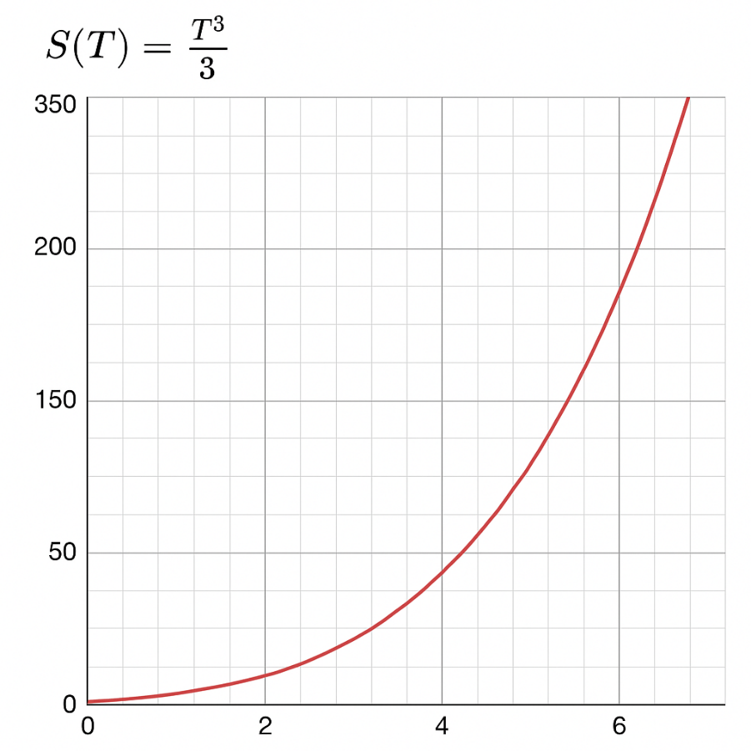

Fig. 1: The graph satisfying the Third law

Fig. 1 shows as the temperatures tend to 0K, the entropy decreases.

## 1.2 Energy and Entropy

One of the thermodynamic properties of a system is its internal energy, *E*, which is the sum of the kinetic and potential energies of the particles that form the system.

In thermodynamics, entropy is a measure of disorder in a system. It quantifies the number of microscopic states that correspond to the given macroscopic state of the system.

The Shannon entropy is a statistical quantifier extensively used for the characterization of complex processes. It is capable of detecting [nonlinearity](https://www.sciencedirect.com/topics/mathematics/nonlinearities) aspects in model series, contributing to a more reliable explanation regarding the nonlinear dynamics of different points of analysis, which in turn enhances the comprehension of the nature of complex systems characterized by complexity and non-equilibrium.

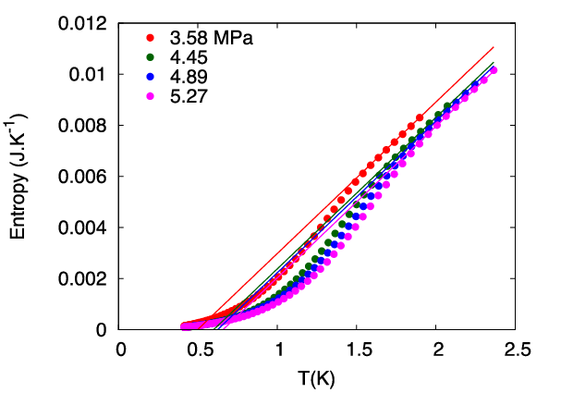

Fig. 2: The entropy ∆S of confined helium-4 versus the temperature T (K) for four pressures. The Kauzmann temperature T is extrapolated with the slope 0.00593 from the upper points

## 1.3 Gibbs Entropy

In statistical mechanics, a system can exist in many possible microstates. Suppose we label these microstates by *i*, and let:

*pi* be the probability of the system being in the microstate *i,*

The sum of all probabilities be normalized:

We want a function S that:

1. Is maximal when all microstates are equally probable (maximum uncertainty),
2. Is additive over independent subsystems,
3. Is continuous in the probabilities ​,
4. Invariant under relabeling of microstates,
5. Reduces to Boltzmann’s entropy in the microcanonical[1] ensemble.

We seek a function. Gibbs showed that the only form consistent with the above properties is:

This is the Gibbs entropy formula.

### 1.3.1 The Interpretation of the Gibbs Formula

is the Boltzmann constant. The expression measures the **average information** (in natural units) or **uncertainty** in the state of the system.

If all microstates are equally probable,, where is the total number of microstates:

Therefore, we obtain the original Boltzmann entropic formula.

Having established the significance of these principles, I shall now move on towards the foundational principles of quantum mechanics.

## 1.4 Helmholtz Free Energy and Gibbs Entropy

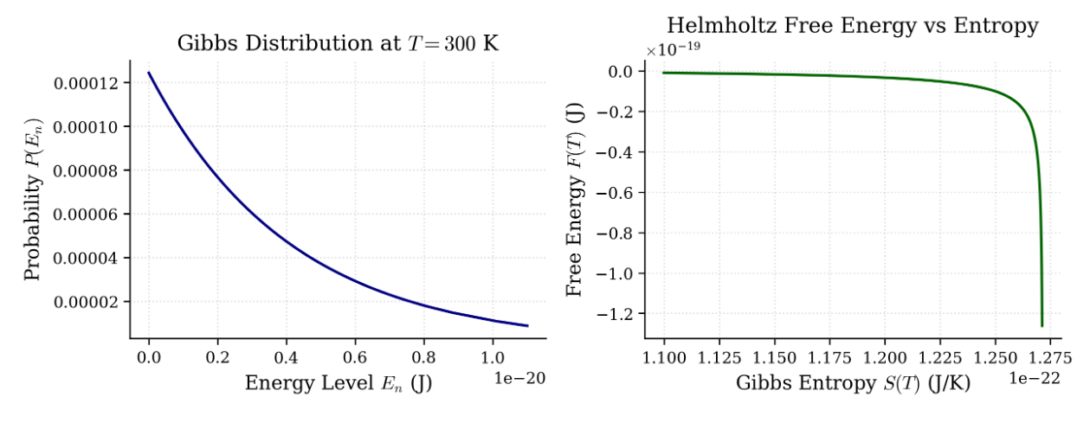

Fig. 3: Helmholtz Free Energy vs Gibbs Entropy

The two plots provide complementary insights into the statistical behavior of a thermodynamic system at thermal equilibrium. The first graph shows the Gibbs distribution at 300 K, where the probability of the system occupying a state decreases exponentially with increasing energy. This reflects the fundamental principle that lower-energy states are statistically more likely at a fixed temperature. The second graph plots the Helmholtz free energy against the Gibbs entropy. It reveals that as entropy increases—signifying greater disorder and a broader distribution over energy states—the Helmholtz free energy sharply decreases. This illustrates how the system moves toward equilibrium by favoring configurations with higher entropy, thereby lowering its free energy. Together, the plots highlight the interplay between microscopic probability distributions and macroscopic thermodynamic potentials, showing how statistical tendencies at the microscopic level drive the macroscopic thermodynamic behavior of the system.

# 2. Foundations of Quantum Mechanics

Quantum mechanics is a theory of the highest cadence which describes the physical universe as we know it. However, while this theory is one of the most accepted theories in the world, the math pertaining to it is quite abstract, and at times, one could argue, quite archaic.

Therefore, in order to understand quantum mechanics in a better way, scientists have come up with postulates that tell us how the math works in the field of quantum mechanics and how measurements in reality correspond to the abstract math of quantum mechanics. In this section, I will briefly discuss these postulates, density operators and mixed states, and the von Neumann entropy.

## 2.1 The Postulates of Quantum Mechanics

Postulate 1: The state of a quantum mechanical system is completely specified by a function Ψ(r, t) that depends on the coordinates of the particle(s) and on time.

Postulate 2: To every observable in classical mechanics there corresponds a linear, Hermitian operator in quantum mechanics.

Postulate 3: In any measurement of the observable associated with operator, the only values that will ever be observed are the eigenvalues that satisfy the eigenvalue equation.

Postulate 4: If a system is in a state described by a normalized wave function Ψ, then the average value of the observable corresponding to is given by,

Postulate 5: The wave function of a system evolves in time according to the time-dependent Schrödinger equation.

Postulate 6: The total wave function of a system with N spin-12 particles (also called fermions) must be antisymmetric with respect to the interchange of all coordinates of one particle with those of another.

## 2.2 Microcanonical, Canonical and Grand Canonical Ensembles

In statistical mechanics, ensembles serve as theoretical constructs that represent a large collection of virtual copies of a physical system, each corresponding to a possible microstate consistent with given macroscopic constraints.

### 2.2.1 The Microcanonical Ensemble

The microcanonical ensemble describes an **isolated system** in which the total energy E, volume V, and number of particles N are strictly fixed. Since no exchange of energy or matter occurs with the surroundings, the system can only occupy microstates that comply with these constraints. Under the assumption of equal a priori probability, each accessible microstate is considered equally probable. The thermodynamic behavior of the system is derived from the entropy, defined via Boltzmann’s relation is the number of microstates compatible with the fixed macroscopic parameters. This ensemble is particularly useful for analyzing completely isolated systems such as closed mechanical systems or certain astrophysical scenarios.

### 2.2.2 The Canonical Ensemble

The canonical ensemble applies to a **closed system** that can exchange energy (but not particles) with an external heat bath. In this case, the temperature T, volume V, and number of particles N are held constant. Unlike the microcanonical ensemble, the system can fluctuate in energy, and the probability of occupying a microstate with energy Ei is given by the Boltzmann factor, where. The central object in this formalism is the **partition function**,

which serves as a generating function for all relevant thermodynamic quantities, such as internal energy, free energy, and heat capacity. The canonical ensemble is widely applicable to systems in laboratory conditions where temperature control is possible, such as ideal gases in thermal contact with a reservoir.

### 2.2.3 The Grand Canonical Ensemble

The grand canonical ensemble extends the canonical framework by allowing the system to exchange both **energy and particles** with a reservoir. The system is characterized by a constant temperature T, volume V, and chemical potential μ. Here, the system’s microstates are described by both energy Ei and particle number N​, and the probability of a given microstate is proportional to the **grand Boltzmann factor The Grand Partition function is defined as**

## 2.3 Density Operators and Mixed States

In quantum mechanics, the state of a system is generally represented either as a pure or a mixed state. A pure state is represented by the unit vector in a complex Hilbert space. The corresponding state operator is given by. A **mixed state** represents a statistical ensemble of different pure states with corresponding probabilities. It is not described by a single vector but by a density operator.

### 2.3.1 Pure and Mixed States

In the prelude to this section, I touched upon the topic of pure and mixed states. In this section, I will discuss these topics in mathematical detail.

In quantum mechanics, the state of a physical system is generally of two types, i.e. it can be represented mathematically by a description of its statistical properties with respect to observable quantities. This description can be given in two ways: as a **pure state** or as a **mixed state**. The distinction lies in the knowledge (or ignorance) of the preparation of the system.

Let be a complex Hilbert space associated with a quantum system. This space is complete with respect to its inner product, and all physical states of the system are represented by operators or vectors in the space.

The pure state corresponds to maximal knowledge of a quantum system. It is represented by a normalized vector, such that,

A pure state can also be represented by the rank one projection operator (also called the state operator),

A pure state implies that if we prepare a large number of systems identically in this state, measurements will yield deterministic statistical predictions. The expectation value of an observable A is:

A **mixed state** describes a statistical ensemble of pure states, each occurring with a certain classical probability. It accounts for **incomplete information** about the system’s precise state. Mathematically, a mixed state is represented by a **density operator**:

Where each is a normalized state vector in, and is the classical probability of the system being in state The properties of mixed state density operators are as follows:

Let be an operator on. Then is a valid density operator if:

A key feature of mixed states is **non-uniqueness of decomposition**: a given density operator ρ can be decomposed in infinitely many ways as mixtures of pure states. That is, different ensembles can yield the same ρ.

### 2.3.2 The Density Operator

Before, I go further, I would like to clarify that density operators and density matrices are essentially the same thing. They are used interchangeably in quantum mechanics.

A density operator (density matrix) on a Hilbert space is a positive semi-definite, trace-class operator with unit trace

Its mathematical properties are as follows,

i) Hermiticity

ii) Positive Semi-definiteness

iii) Unit trace

iv) Idempotency (for pure states only)

If, the state is mixed.

## 2.4 von Neumann Entropy

The von Neumann entropy, like any other form of entropy measures the entropy of a system. It was developed by John von Neumann. It quantifies the amount of randomness or mixedness in a quantum state, with a pure state having zero entropy and a maximally mixed state having maximum entropy.

### 2.4.1 Classical Entropy

The classical entropy of a probability distribution is given by the Shannon entropy,

For a classical statistical ensemble, the entropy is given by the Gibbs entropy (section 1.3),

These definitions will be helpful to us in the derivation pertaining to the von Neumann entropy.

### 2.4.2 Derivation via Spectral Decomposition

Let be a density operator. Since is Hermitian and positive semi-definite, it admits a spectral decomposition,

Where,,, and is an orthonormal basis eigenvectors.

Then,

Assuming, λ*i*​ > 0 for all *i*, and defining log 0= −∞ but 0 log (0) = 0 in limit.

So,

and thus,

which is just the Shannon entropy of the eigenvalue distribution of.

### 2.4.3 Properties of von Neumann Entropy

Let be a density operator on Hilbert space. Then,

i) Minimum:, iff is a pure state.

ii) Maximum: if

iii) Unitary Invariance[2]:

iv) Concavity[3]: The map is concave.

### 2.4.4 The von Neumann Entropy for the Excited He Atom

The **helium atom**, particularly in its **excited 1s2s configuration**, provides a rich platform for studying quantum entanglement through the lens of **von Neumann entropy**. In this state, the two electrons occupy different orbitals but remain coupled via their mutual Coulomb interaction and the requirements of antisymmetry imposed by the Pauli Exclusion Principle. As a result, the overall wavefunction—whether in the **singlet (¹S)** or **triplet (³S)** spin state—is not separable, leading to a **mixed reduced density matrix** when one electron is traced out. The von Neumann entropy of this reduced density matrix quantifies the entanglement between the electrons. Calculations based on Hylleraas or configuration interaction methods typically yield entropy values in the range of **0.45 to 0.70 bits**, depending on the spin state and the level of excitation. These values indicate that while the electrons are not maximally entangled, there exists a **significant degree of quantum correlation**. The entropy is slightly higher in singlet states due to their greater spatial overlap, which increases the indistinguishability and coupling between electrons. Thus, the von Neumann entropy in excited helium not only reflects the **internal structure and symmetry of the atomic state**, but also serves as a concrete manifestation of quantum entanglement in a physically realizable system.

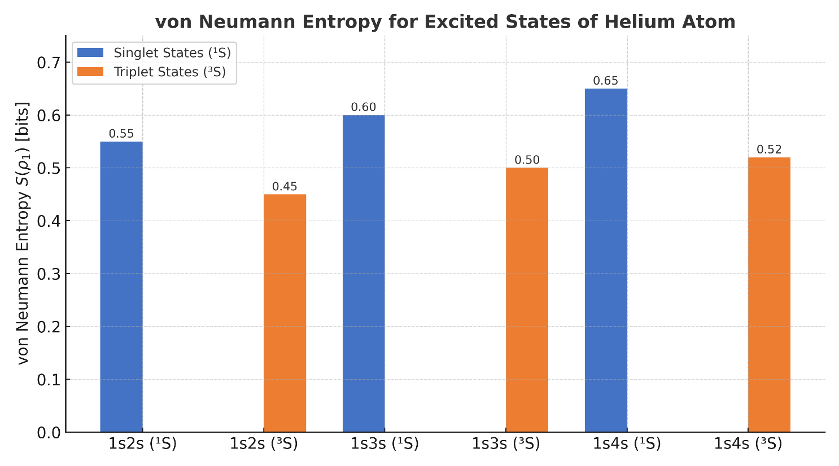

Fig. 4: The von Neumann entropy for Excited States of He

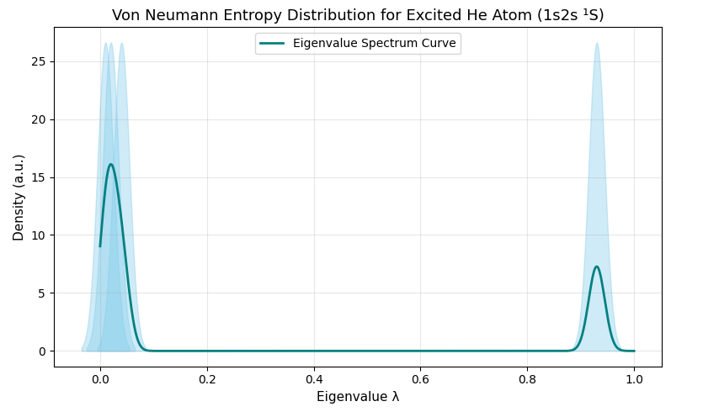

Fig. 5: The von Neumann Entropy Distribution for the Excited He Atom

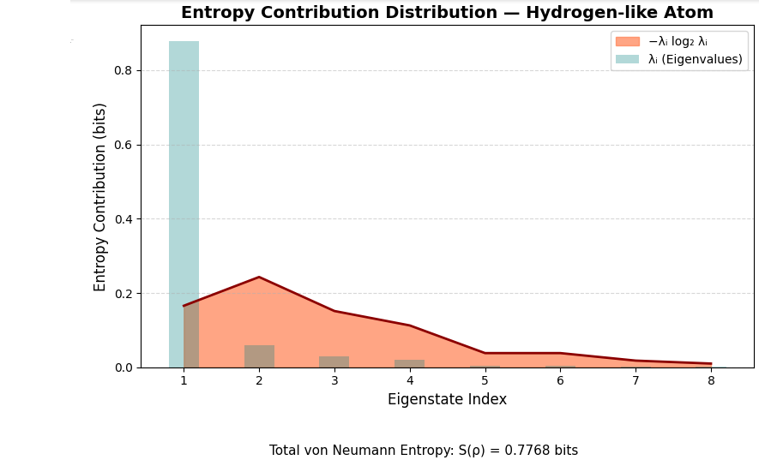

Fig. 6: The von Neumann Entropy Distribution for a Hydrogen-like Atom

Lin & Ho (2013) calculated von Neumann entropies for the 1s2s1,3S excited states of the helium atom and related helium-like ions, showing entanglement increases with Z and reports results for Z=2 (He). Further, Chien‐Hao Lin & Yew Kam Ho (2014) used Hylleraas-type wave functions to obtain benchmark entropy values for singlet and triplet 1sns S states (n=1 to 6), including 1s2s, via Schmidt–Slater decomposition.

With this, I will mark the end for this section. I will now move on to the proceeding section.

# 3. Bridging Classical and Quantum Thermodynamics

The inconsistencies of classical mechanics with respect to quantum mechanics is still prevalent. This is seen in the inconsistencies of classical and quantum thermodynamics. One of these inconsistencies is the famous “arrow of time”. This subject has attracted substantial attention in both foundational and applied quantum thermodynamics. Should we find the nature of time, we may get surreal applications of reversibility or a more well-known application, we will possibly have a path to build a working device which can change its position in time, i.e., it can change its temporal properties. The term arrow of time was coined by British astrophysicist Arthur Eddington.

## 3.1 The Arrow of Time

As discussed above, the arrow of time is quite an intriguing topic, for it promises wondrous applications regarding reversibility. However, it does raise some questions. Do we really know the direction of the arrow of time? It has been proposed that different physical systems may experience temporal asymmetry in distinct ways. However, many philosophers and physicists claim that this direction is from the past to the present. The Roman poet Ovid tried to refer to this one-way property of time when he said,

Time itself glides on with constant motion, ever as a flowing river.

This poses a rather philosophical question, where does this arrow of time originate? This question divides the intellectuals into two parties. The first party argues that this arrow is an intrinsic, inherent property of time. The second party argues the arrow is not intrinsic to time itself but instead is all the physical processes that happen to go regularly and naturally in only one direction. From a thermodynamical point of view, the intellectual raises the question, what grounds the thermodynamic asymmetry in time? In a world governed by time-symmetric laws, how do the time-asymmetric thermodynamic laws of time arise? An extension of this question would be, does the thermodynamic asymmetry have any other asymmetries? Does it account for the fact that we know more about the past than the future? The discussion thus divides between thermodynamics being an explanandum[4] or explanans[5].

## 3.2 The Lindblad Master Equation

I will be deriving the Lindblad Master Equation in this section. It describes the time evolution of a quantum system that is interacting with its environment, resulting in a loss of quantum coherence[6] and energy.

Let us consider the system-bath interaction is of the form,

where is a general operator that acts only on the principal system S, and is an operator that acts only on the bath B. Now, we consider that commutes with, i. e.,

Resulting in,

Let us consider the bath Hamiltonian defined by a bath of bosons,

Where, and are creation and annihilation operators respectively, is the characteristic frequency of each mode, and the operator is defined as

where *gk* are complex coefficients representing coupling constants. Then, in the interaction[7] picture,

Expanding each exponential and commutator in the previous equation,

The interaction with the definition resembles the Jaynes-Cummings one, which represents a single two-level atom interacting with a single mode of the radiation field[8].

I will now solve a commutator in the Born-Markov equation. The commutator is of the form,

To solve this, we will expand every single term of this commutator. However, the expansion[9] is quite a drawn-out, tedious procedure, therefore, I will skip directly to the important result,

Now, I will expand both of these terms individually for greater clarity,

Now, we will expand these two equations further and group the similar terms to obtain,

and,

Now, we are in a position to take the trace of the two equations,

With this[10],

and,

Now, we will return to the original commutator, and obtain,

For convenience, we will define the functions,

Then,

Substituting these values in the Born-Markov Master equation,

Actually, the usual Lindblad equation emerges when G(t) = 0 and F(t) = F*(t). In order to obtain the equation, we must take numerous approximations which are outside the scope of this paper. Therefore, I will skip to the Lindblad equation which is of the form,

The operators are called the Lindblad operators. That concludes the derivation for the Lindblad Master equation.

## 3.3 Quantum Analogs of Classical Thermodynamic Quantities

As thermodynamics transitions into the quantum domain, it necessitates a reformulation of core ideas of classical methods in order to be in accordance with the laws of quantum mechanics. Some of these ideas are things which are fundamental in classical thermodynamics such as entropy, equilibrium distributions, free energy, and temperature. These ideas need to be formalized while making a transition to quantum mechanical thermodynamics. This section will provide a mathematical treatment of these key thermodynamic concepts reformulated in quantum terms.

### 3.3.1 Quantum Thermal States

A quantum thermal state describes a system in equilibrium with a reservoir at temperature T, under the assumption that the system can exchange energy, but not particles. It is a mixed state represented by the density operator on the system’s Hilbert space, defined via the Gibbs distribution,

Where, H is the Hamiltonian of the system, Z is the partition function, and is the inverse temperature.

### 3.3.2 The Derivation of the Gibbs Distribution

Given a system with a Hamiltonian H, we seek the state that maximizes the von Neumann entropy under the constraints of

The von Neumann entropy is given by,

Now, we will define the functional[11],

We will now take the variation with respect to , treating it as a matrix valued variable,

Set for an arbitrary , we get,

Solving for ,

Now, we will normalize to obtain,

### 3.3.3 Properties of the Gibbs Quantum State

is trace class[12] if H has a discrete spectrum bounded from below. This ensures Z is less than infinity and is well defined. It is a positive definite state, i.e., , hence has full support on . It describes a mixed state unless T = 0 (then it projects onto the ground state).

The Gibbs state is time-independent. It commutes with H as,

So, under unitary evolution,

### 3.3.4 The Spectral Decomposition of the Gibbs State

Let be an orthonormal basis of eigenstates of H, with, then,

This is analogous to the classical Boltzmann distribution,

but now, the probability is assigned to the quantum eigenstate .

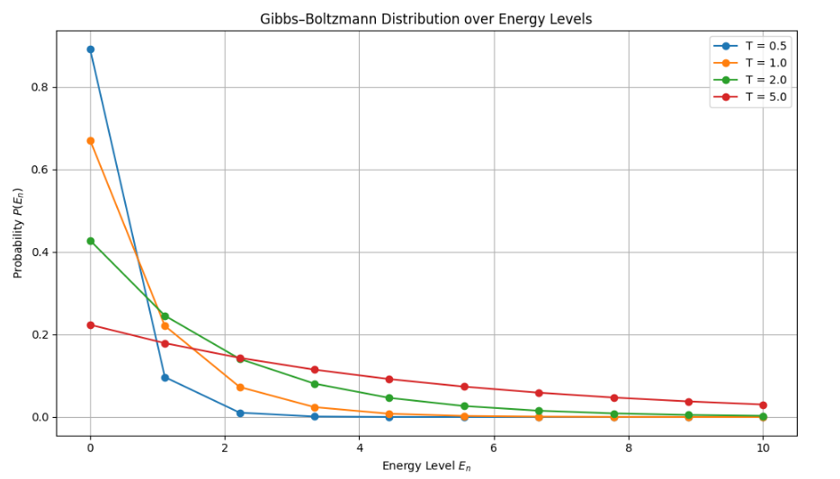

Fig. 7: **Gibbs distribution** (also called the **Boltzmann distribution**) for a system with discrete energy levels, at different temperatures.

As **temperature increases**, the distribution becomes **broader**; higher energy states become more probable. As **temperature decreases**, it becomes **sharply peaked** at the **lowest energy**.

## 3.4 Free Energy in Quantum Systems

The Helmholtz free energy, denoted by either A or F, represents a thermodynamic potential that measures the maximum amount of useful work obtainable from a closed thermodynamic system at a constant temperature.

The equation is of the form,

Where, U is the total internal energy of the system, T is the temperature and S is the entropy.

Free energy quantifies the balance between a system’s internal energy and the amount of disorder or uncertainty in the system, which in the quantum context is measured by entropy. A system with low entropy (high order) can potentially be harnessed to do more work, while one with high entropy (greater randomness) has less free energy available.

Understanding free energy in this context is essential for emerging fields like quantum information and quantum technologies, where the goal is often to extract work, transmit information, or perform computations in the most efficient way possible. It provides a framework for identifying which transformations are possible, how much energy they cost, and how quantum effects might provide new advantages — or impose new limitations — compared to classical physics.

# 4. Quantum Definitions of Work, Heat, and Energy

As previously established, when making a transition from classical thermodynamics to quantum mechanical thermodynamics, one must reformulate the classical definitions in order to be consistent in the quantum realm. In this section, I will provide some of these definitions.

## 4.1 The Two-Point Measurement Scheme

The two-point measurement scheme is a method used in quantum thermodynamics to analyze the work done on or extracted from a quantum system during a process. It is a fundamental protocol in quantum thermodynamics and quantum statistical mechanics.

Let us assume that we have a quantum system described by the Hamiltonian H(0). The system evolves under a time-dependent Hamiltonian from t = 0 to t = , ending with H().

We will now perform a projective measurement[13]of the system’s energy using the eigenstates of the initial Hamiltonian H(0). The system will collapse into an eigenstate with energy , with probability,

Where, is the initial density matrix of the system. Now, we will evolve this system unitarily under the time-dependent Hamiltonian,

where, denotes time ordering. No measurement is made during this time. The system's state changes due to external driving, not due to interaction with a heat bath.

At the final time , we make another projective measurement, now using the eigenstates of the final Hamiltonian H(). The system then collapses into the eigenstate with probability,

The work done on a single realization is,

The probability distribution for work is given by,

### 4.1.1 The Joint Probabilities of the Eigenvalues

The joint probability of measuring then is given by,

## 4.2 Work and Heat in Open Quantum Systems

An open quantum system S interacts with an environment or a bath B. The total Hamiltonian is,

Here, the system Hamiltonian HS is possibly time-dependent, leading to work. HB is the Hamiltonian of the bath and Hint is the interaction Hamiltonian.

We describe the evolution of the system using a **reduced density matrix** , obtained by tracing out the bath. One may consider the following application of the Leibniz product rule,

And decide that the first term corresponds to work and the second one to heat. In stochastic thermodynamics, heat and work can be defined using quantum jump trajectories. Work is associated with coherent evolution under a time-dependent Hamiltonian. Heat is associated with quantum jumps (non-unitary effects). Another way to define heat is through energy change in the environment,

In practice, this is often inaccessible, but it underlies formal definitions.

Seegebrecht and Schilling [27] have identified different sources of work such as coherence (from superposition), correlations between the systems and the environment, and frequency offsets[14] in interaction. These offsets can significantly affect how energy is being exchanged. Seegebrecht and Schilling are of the opinion that these offsets complicate how we partition energy into heat and work. Their work clarifies how the conceptual split among **different definitions of energy exchanges** affects theoretical predictions in quantum thermodynamics. They have taken a minimal dissipation[15] approach wherein they optimize the decomposition to minimize the dissipation, yielding a preferred effective Hamiltonian and clear separation of work and heat. The authors have split the Hamiltonian into three parts: system accessible, environment accessible, and binding energy. Seegebrecht and Schilling have quite cleverly defined the variables. As discussed in the paper [27], **ambiguities arise** in labeling environments strictly as "heat" or "work" sources; in many cases they act as **hybrid reservoirs**.

The minimal-dissipation method is preferred as it offers clear definitions, is applicable generally, and minimizes unphysical dissipation.

## 4.3 Temperature in the Context of Quantum Thermodynamics

In **quantum thermodynamics, temperature** remains a central concept, but it must be reinterpreted to align with quantum mechanical principles. In classical thermodynamics, temperature is a measure of the average kinetic energy of particles in a system, and it appears naturally in the Boltzmann distribution,

Here, is the familiar inversion temperature, Z is the partition function and p is the probability of the system of it being in that energy state. In quantum thermodynamics, temperature is defined by the density matrix and not by a simple probability distribution. It is of the form,

Where, H is the Hamiltonian of the system and in order to ensure normalization, and is just the inversion temperature.

Temperature controls the *statistical weight* of energy eigenstates in the thermal density matrix. It tells you how likely the system is to occupy higher or lower energy states. In **resource-theoretic quantum thermodynamics**, temperature is associated with the **thermal operations** the system undergoes, e.g., those that preserve the Gibbs state. For **non-equilibrium** quantum systems, an **effective temperature** may be defined **locally**, for say, a small subsystem using:

However, this is only valid when the subsystem approximates a thermal state. In systems with **bounded spectra**[16] (e.g., spin systems), **negative absolute temperatures** can be defined. These correspond to **inverted populations**higher energy states are more populated than lower ones:

## 4.4 Energy in the Quantum Context

In quantum mechanics, the energy of a system is a fundamental quantity which is associated with the Hamiltonian operator of the system. Unlike in classical physics, where energy is a real number, in quantum mechanics, energy is defined per valores proprios*[17]* of an operator acting on a Hilbert space. As I have iterated, the energy of the quantum state is defined by the Hamiltonian of the system. This operator governs the time evolution of the wave function via the Schrödinger equation,

Here, the **eigenvalues** of are the **possible energy levels** of the system. is a Hermitian operator, ensuring real eigenvalues (measurable energies). A system is in an energy eigenstate if,

is the energy eigenvalue, and is the corresponding eigenstate. These states are also called **stationary states** because their probability distributions do not change in time. In many quantum systems, energy is **quantized**, meaning it can only take on **discrete** values. For instance, the energy in the Hydrogen atom is given by,

For a general quantum state , the expected energy (average measurement outcome) is,

This is analogous to the average value in classical statistical mechanics. In quantum thermodynamics, energy takes on a unique manifestation wherein it connects to the temperature via the Gibbs state,

Energy is crucial in defining **work, heat**, and **entropy production** in microscopic systems.

In quantum mechanics, energy is no longer a simple scalar quantity as in classical physics, but a fundamental observable represented by the Hamiltonian operator. Its values arise per valores proprios of this operator — the eigenvalues that define the system’s possible measurable energies. These discrete or continuous spectra not only govern the time evolution of quantum states but also determine thermodynamic properties when extended into the realm of quantum thermodynamics. Thus, energy in the quantum context is deeply tied to the structure of Hilbert space, operator theory, and the probabilistic nature of measurement, offering a richer and more nuanced framework than its classical counterpart.

# 5. Quantum Entropy and Thermodynamic Potentials

Thermodynamic potentials are basically state functions that represent the energy of a system and are used to determine the system's equilibrium state and predict the direction of spontaneous processes. These along with their corresponding state equations, describe the equilibrium behavior of a system as a function of so-called “natural variables”. The natural variables are a set of appropriate variables that allow to compute other state functions by partial differentiation of the thermodynamic potentials.

There are four basic thermodynamic potentials. They are, internal energy, enthalpy, Gibbs enthalpy, and free energy. In this section, I will cover the mathematical basis for these four basic potentials. This section will also contain a comparison between the von Neumann and Shannon entropies and highlight their differences.

## 5.1 A Comparison of Quantum and Classical Thermodynamic Entropies

The von Neumann and Shannon entropies play a major role in quantum and classical thermodynamics respectively. The von Neumann entropy is thought to be the whole quantum extension of the Shannon and Gibbs entropies. Shannon entropy quantifies information for classical systems. Its quantum analogue extends this to quantum systems capturing both probabilities and quantum coherences. The von Neumann entropy also captures entanglement. As discussed, the von Neumann entropy is given by,

The Shannon entropy is given by,

If the density matrix ρ is diagonal (i.e., corresponds to a classical probabilistic mixture), then,

Where, will be the eigenvalues of ρ. This shows that Shannon entropy is a special case of the von Neumann entropy. As I have iterated, if the density matrix is diagonal, the Shannon and von Neumann entropies are the same. However, under other circumstances, the von Neumann entropy is generally lower than the Shannon entropy, this suggests that information can be compressed more effectively. The von Neumann entropy can be used to analyze how **quantum systems undergo decoherence** into classical ones, where the density matrix becomes diagonal in the pointer basis and von Neumann entropy converges to Shannon entropy. This boundary is important in understanding the classical emergence from quantum mechanics. At zero entropy, the Shannon entropy gives a certain classical even. The von Neumann entropy gives a pure state at zero entropy. When the Shannon entropy is maximum, a uniform probability distribution is obtained. At the maximum von Neumann entropy, a maximally mixed state will be obtained.

In summation, Shannon entropy is to classical thermodynamics as von Neumann entropy is to quantum thermodynamics. The two are mathematically analogous and operationally distinct, with von Neumann entropy presuming the role of Shannon entropy when the classical probability distributions are treated as diagonal density matrices.

## 5.2 The Thermodynamic Potentials

**Thermodynamic potentials** are scalar quantities that encapsulate the energy content of a system under specific constraints, serving as essential tools for analyzing equilibrium and spontaneous processes. Each potential such as internal energy, Helmholtz free energy, Gibbs free energy, and enthalpy arises from Legendre transformations of the internal energy and is suited to different thermodynamic conditions. By examining which potential is minimized in a given setting, we can predict the direction of natural processes and determine equilibrium states. These functions bridge energy, entropy, and external variables, providing a unified framework for the laws of thermodynamics.

### 5.2.1 The Internal Energy Potential

A basic relation in thermodynamics is given by,

where {F, q} denote the set of conjugate intensive and extensive variables that characterize a system. For a gas,

The number of particles of a distinct type *j* is given as in the equation. Here, . The respective intensive variable, µ (and respectively the µj ), is denoted the chemical potential. The chemical potential becomes identical to the Fermi energy for a gas of Fermions[18] (at low temperatures). The internal energy of a gas is equivalent to,

For a gas with one species of particles. This implies,

### 5.2.2 The Legendre Transformation

The usage of the internal energy potential as creates a disadvantage. It is as follows, since in a lab, S can’t be controlled, it is not preferred to use the form discussed above. Therefore, for reasons of practicality, it is easier to deal with other thermodynamic potentials that can be defined using Legendre transformations.

In classical mechanics, the Legendre transformation connects the Legendre function to the Hamilton function , where q is the generalized coordinate and and denote the velocity and momentum respectively, with

at constant coordinate q, and,

Therefore, a Legendre transformation is a variable transformation , where one of the variables (in this case, the momentum), is defined by the slope of the original function, viz. the slope of the Lagrange function.

### 5.2.3 The Enthalpy Potential

**Enthalpy** is a thermodynamic quantity that measures the **total heat content** of a system. It is especially useful when studying processes that occur at **constant pressure**, which is common in chemistry and atmospheric science.

We are presented with the transformation,

from the internal energy U to the enthalpy H.

The pressure is defined as the negative slope of the internal energy with the volume. The Legendre transformation allows to evaluate with,

the differential dH of the enthalpy in terms of its natural variables S, P and N.

This is the mathematical form of the enthalpy potential.

### 5.2.4 The Gibbs Enthalpy Potential

The **Gibbs enthalpy**, more commonly known as the **Gibbs free energy** G, is a **thermodynamic potential** that is especially useful for processes occurring at **constant temperature** and **constant pressure**—conditions common in chemistry, biology, and many engineering systems.

As discussed in the previous sections,

The Gibbs enthalpy has the form,

We will now differentiate to obtain,

Therefore, we obtain,

which is the form of the Gibbs enthalpy.

### 5.2.5 The Free Energy Potential

In thermodynamics, **free energy** refers to the part of a system's total energy that is **available to do useful work** under specified constraints. While internal energy U provides a complete description of a system's microscopic energy content, it is not always the most convenient quantity for describing natural processes—especially when **temperature** and **pressure** are held constant, as in most chemical and biological systems.

For deriving the differential form of the free energy potential, we will follow a similar procedure to section 5.2.5. The free energy potential is of the form,

Differentiating the equation,

This is the differential form of the free energy potential.

# 6. Quantum Resource Theories and the Second Law of Quantum Thermodynamics

In many areas of physics, especially quantum thermodynamics, we are often constrained by physical rules—such as conservation of energy or limited access to systems that are already in thermal equilibrium. Quantum Resource Theories (QRTs) offer a systematic way to study these limitations by dividing quantum states and operations into two categories: those that are free to use and those that are considered valuable resources. Free operations are those allowed under the given constraints, while resourceful states are those that enable us to perform tasks, such as extracting work, that free states alone cannot accomplish. In quantum thermodynamics, thermal equilibrium states (called Gibbs states) are treated as free, and any departure from equilibrium represents a resource. This framework leads naturally to a deeper understanding of thermodynamic laws at the quantum level. In particular, the second law of thermodynamics—which states that entropy must increase in closed systems—has several **quantum generalizations** when viewed through the lens of QRTs. Rather than a single law, we obtain a family of **generalized second laws**, which place stricter conditions on how quantum states can evolve under free (thermal) operations. These include constraints based on entropy, energy, and more refined quantities such as **quantum Rényi divergences**, which capture the limitations of state transformations in the quantum regime. Together, resource theories and these generalized laws provide a powerful framework for understanding what kinds of thermodynamic processes are possible—or impossible—when dealing with quantum systems.

## 6.1 The Second Law of Quantum Thermodynamics

As discussed above, in quantum thermodynamics, we obtain generalizations of the second law. In this section, I will discuss this law and also its generalizations.

The second law of thermodynamics says that the entropy of a system never decreases, i.e., it is never negative. That implies,

In the quantum context, we use the von Neumann entropy. This entropy increases under completely positive, trace-preserving (CPTP) maps when the evolution is unitary or under thermal operations. A **CPTP map** is a **completely positive trace-preserving map,** which is the most general type of quantum operation (also called a **quantum channel**) that transforms density matrices into other valid density matrices. In **resource theories**, restricting allowed CPTP maps defines the **physical constraints** (e.g., energy conservation, locality), while the CPTP property ensures valid quantum evolutions.

For non-isolated systems evolving under Lindblad–Gorini–Kossakowski–Sudarshan (LGKS) dynamics, **Spohn’s inequality** gives,

Here, is the Lindbladian superoperator, and is the stationary state which is typically a thermal state, and this ensures that the total entropy production is non-negative,

This inequality is called Spohn’s inequality and it is a cornerstone in quantum thermodynamics and generalizes the second law to quantum Markovian processes[19].

### 6.1.1 The Second Law from a Resource-Theoretic Perspective

The quantum resource theory of quantum thermodynamics introduces a family of generalized free energies. For a state and thermal state ,

These Rényi-type free energies obey,

Here, is a generalized free energy defined as,

Where, is the state of the system, is the Gibbs state at inverse temperature , and is the relative Rényi entropy between and , and is a real parameter indexing the family of free energies. This leads to a **hierarchy of second laws**—a central result of resource-theoretic thermodynamics [16].In the macroscopic limit, they all converge to the standard free energy,

Measurement and feedback introduce informational contributions to entropy production. A key result of this is the reflection of the Landauer Principle in the quantum regimes,

Where is the mutual information gained through the measurement. Generalizations from Sagawa and Ueda [33] show how information directly influences thermodynamic bounds.

The second law of quantum thermodynamics extends the classical principle of entropy increase into the quantum regime by incorporating the structure of quantum states, open system dynamics, and informational constraints. Using tools like the von Neumann entropy, Spohn’s inequality, and generalized free energies ​, it provides a rigorous mathematical framework for understanding irreversibility in quantum processes. These formulations reveal that thermodynamic behavior persists at the microscopic scale, though governed by a richer set of laws that account for coherence, correlations, and statistical fluctuations.

## 6.2 Quantum Resource Theories (QRT)

A **quantum resource theory** is a mathematical framework used to study which quantum states are useful (i.e., "resources") for specific tasks, and which operations are allowed (usually called **free operations**) under some physical or operational constraints. In this section, I will cover the basis for these theories. A quantum resource theory has free states, i.e., states that are easy to prepare under a set of given conditions. In QRT, operations allowed without consuming resources (e.g., operations that obey energy conservation, locality, or classical control) are called free operations. Quantum states that cannot be created using only free operations and free states, and therefore possess some kind of “quantum value” or “resource”. While I will not discuss monotones in this section, I will provide a basic definition on the topic. Monotones are quantities that do not increase under free operations, instead, they are quantities that decrease (or remain invariant). These help quantify how much of a resource a state has.

In this section, I will discuss the entanglement resource theory, coherence theory, and more.

### 6.2.1 The Entanglement Resource Theory

Let there be a bipartite Hilbert space given by,

The free states of the entanglement resource theory are separable states. A state is said to be separable if it can have the form,

Here, and,

The set of all such states forms the convex set .

In the entanglement theory, a free operation is an operation such that it is a LOCC (Local Operations and Classical Communication). A CPTP (completely positive trace-preserving) map is LOCC if it can be decomposed into local operations on *A* and *B*, possibly coordinated through classical communication.

The characterization of all LOCC maps is known to be quite a difficult endeavor, which motivates the usage of larger sets such as separable operations,

### 6.2.2 Asymmetry and Quantum Reference Frames

Shannon theory posits information is *fungible[20]*. Information can be encoded into any degree of freedom of any physical system, and the information content is independent of the choice of encoding.

In information theory, fungible information characterized by the ability to be transmitted via a string of words or verbally, is called speakable information. On the other end of the spectrum, there exists a non-fungible type of information such as the time of some event, or the relative phase between two quantum states in superposition. This type of information is called unspeakable information since it cannot be communicated verbally without the presence of a (in this case), a synchronized clock, or a common phase reference.

It is found that unspeakable information becomes speakable in the presence of a reference frame. This is applicable to both classical and quantum information. However, even though the information is fungible, two parties must establish how this information will be encoded or decoded in a physical system. This requires a common reference frame. Thus, one always assumes a shared reference frame in the background of any quantum information processing task, and the absence of this greatly limits what can be accomplished.

Let *G* be a compact Lie group[21] . The group acts on a system’s Hilbert space via a unitary representation,

Here, the free states are symmetric states. A state is said to be symmetric if,

In this theory, the set of free states is given by,

Free operations are covariant channels. A CPTP map is covariant if,

These define the resource theory of **asymmetry**, which quantifies the lack of symmetry (i.e., the ability to function as a reference frame).

### 6.2.3 Thermodynamic Non-Equilibrium as a Quantum Resource

In this section, I will discuss the formalization of thermodynamic non-equilibrium (athermality) as a quantum resource. The idea here is that thermal equilibrium states at a fixed temperature are free, and operations that do not create non-equilibrium (athermal) states are allowed.

The resource theory of athermality is fundamental in **quantum thermodynamics,** and it is structured by physical constraints: conservation of energy, interaction with a thermal environment, and no external work being done.

Let be a finite dimensional Hilbert space. Let be the Hamiltonian of the system and let be the familiar inverse temperature.

For a fixed system[22], the only free state is the Gibbs state at the inverse temperature,

More generally, the free states are those of the form ​ for bath systems, or Gibbs states of arbitrary systems with known Hamiltonians. Free operations in this context are thermal operations. Thermal operations are CPTP maps that model physical processes allowed by thermodynamics when no work is performed, and the system only interacts with a heat bath at a fixed temperature. As established in section 6.1, a quantum channel is a thermal operation on a system *S* if there exists an ancilla[23] (heat bath) B with the Hamiltonian *HB* and the bath is in a thermal state (Gibbs state) given by,

Further, a global unitary operator U acting on that commutes with the total Hamiltonian to give,

This ensures energy conservation. We get the resultant operation as,

This defines the set of thermal operations. Here, only heat exchange is permitted and work is forbidden. In the non-equilibrium theory, the resource is thermodynamic non-equilibrium (athermality) itself.

Any state such that,

is a resource. It represents athermal behavior. Since these states are resources, such states can potentially be used to extract work, refrigerate, or perform other tasks.

### 6.2.4 Energy-Incoherent States and Thermo-majorization in the Context of Athermality

To be energyincoherent means that a quantum state has no coherence between different energy levels — that is, it is diagonal in the energyeigenbasis of the system's Hamiltonian.

When the density matrix is diagonal in the energy eigenbasis of *HS*, the problem is reduced to classical stochastic thermodynamics.

Let,

Then, the Gibbs state will be given by,

In such a context, the necessary condition for a transition of states from under thermal operations is given by,

Here, “” represents the condition for thermo-majorization. Therefore, thermo-majorization is a fundamental concept used in quantum thermodynamics which compares the spread of probability distributions of quantum states, particularly in the context of thermalization. It essentially gives us a way to determine if one state is more “mixed” than another state with respect to a reference Gibbs state. In other words, it can be considered as a generalization of classical majorization[24] weighted by Gibbs factors.

### 6.2.5 The Thermo-Majorization Curve

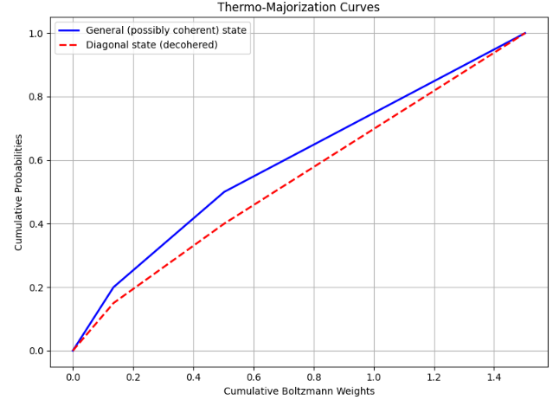

Fig. 8: Thermo-majorization curves for a general quantum state (solid blue) and its energy-diagonal counterpart (dashed red). The curves plot cumulative occupation probabilities against cumulative Boltzmann weights. The deviation between the two reflects the contribution of quantum coherence, which is inaccessible under thermal operations.

The figure above displays thermo-majorization curves for two quantum states: a general (possibly coherent) state and its energy-diagonal (decohered) counterpart. The x-axis represents the cumulative **Boltzmann weights** ​, sorted according to the Gibbs-rescaled probabilities, while the y-axis represents the corresponding **cumulative occupation probabilities**. The **blue solid line** corresponds to the thermo-majorization curve of the general state, which may contain quantum coherence, while the **red dashed line** represents the curve of its dephased (energy-incoherent) version. The vertical difference between the curves illustrates how coherence can enhance the ordering of a state relative to thermal equilibrium, though such coherence is not accessible under standard thermal operations. Thermo-majorization provides a necessary and sufficient condition for state convertibility under thermal operations in the absence of coherence: a state ρ can be transformed into σ if and only if the thermo-majorization curve of ρ lies entirely above that of σ.

### 6.2.6 The Coherence Resource Theory

Quantum coherence is a fundamental part of quantum theory as it gives the basis for many pivotal theories, for instance, the coherence theory I am about to discuss. To be coherent means to be superposed between basis states. In other words, if the basis states are in a superposition they are coherent. It is basis-dependent and becomes operationally meaningful when we **fix a reference basis** (usually motivated by physical constraints like energy conservation, measurement protocols, etc.). Coherence as a resource theory was introduced by Baumgratz et al. [32].

In coherence resource theory, incoherent states are free states. We define an incoherent state by the following,

Fix a reference basis for the system’s Hilbert space . Therefore, the incoherent states are density operators diagonal in this basis,

These represent **classical mixtures** with no coherence in the specified basis. There are multiple choices for free operations. They are however, dependent on the constraints set on the usage and generation of coherence. Operations such as incoherent operations, maximally incoherent operations, strictly incoherent operations, and physically incoherent operations are available. A quantum state is said to possess coherence if it is not diagonal in the chosen basis.

Coherence theory poses a question regarding the transformation of a state under free operations. **Pure state transformations** under incoherent operations are completely characterized by **majorization** of the squared amplitudes. **Mixed state transformations** are more complex and involve coherence monotones or catalysis.

# 7. Quantum Fluctuation Theory in Nonequilibrium Thermodynamics

Quantum fluctuation refers to an esoteric change in the energy levels of a quantum system. Quantum fluctuations are a direct consequence of Heisenberg’s Uncertainty Principle which states that certain pairs of physical properties, like energy and time, cannot be known with perfect accuracy simultaneously. This section will contain a rigorous derivation of the Jarzynski equality, the quantum equivalent of Crook’s Theorem, and will contain terminologies and concepts pertinent to fluctuation theory and the link between fluctuation theory and quantum thermodynamics.

## 7.1 Introduction to Quantum Fluctuation Theorems

A theory of quantum fluctuation was introduced as a way to circumvent the inconsistencies of classical thermodynamics in the quantum regime. In quantum thermodynamics and quantum fluctuation theorems, thermal and quantum fluctuations help us in understanding irreversibility, entropy production, and the probabilistic nature of work and energy exchanges in small or quantum systems.

Thermal fluctuations refer to the random deviations from equilibrium behavior in a system due to its interaction with a thermal environment at nonzero temperature. Quantum fluctuations refer to the intrinsic uncertainty in observables arising from the non-commutativity of quantum operators and the probabilistic nature of quantum measurement. Thermal fluctuations arise even in the absence of quantum fluctuations and are significant in the classical domain (i.e. large systems). In thermally driven systems, work and heat become stochastic quantities, and fluctuation theorems such as the **Jarzynski equality** and **Crooks theorem** quantify these stochastic behaviors. Thermal fluctuations are responsible for deviations from time-reversible microscopic dynamics, giving rise to macroscopic irreversibility and entropy production. Quantum fluctuations on the other hand, are present at even at absolute zero due to the Uncertainty Principle. Further, in quantum thermodynamics, the act of measurement itself can introduce fluctuations in energy due to back-action. Quantum fluctuations can be enhanced or suppressed depending on the quantum coherence or entanglement present in the initial state. In quantum fluctuation theorems, energy measurements at different times do not generally commute, introducing a purely quantum source of fluctuation.

The total **irreversibility** observed in a process can be decomposed into contributions from both types of fluctuations. Quantum fluctuation theorems generalize classical ones by incorporating this duality, often by formalizing expressions in terms of the **quantum relative entropy, quantum work distribution**, and **non-equilibrium free energy**.

## 7.2 The Quantum Jarzynski Equality

The Jarzynski equality is a formula in statistical mechanics that relates the free energy difference between two equilibrium states to the work done during an irreversible process between those states. In this section, I will discuss a derivation of the Jarzynski equality. This derivation will be carried out under the standard two-point measurement scheme.

Let us assume a quantum system with system Hamiltonian *H(t),* evolving from time *t=0* to t=. The initial state is to be the Gibbs state,

Here, is the familiar partition function given by,

The system evolves under a unitary operator *U* generated by *H(t),* i.e., . Work is defined through projective energy measurements at *t =* 0 to *t = .*

Let be the eigenstates of H(0) with eigenvalues , and be those of H(), with eigenvalues . Therefore, as discussed in section 4.1.1, the joint probability of measuring both these eigenvalues is given by,

Now, we will define the work done to be given by,

Therefore, the average of is given by,

Now, we will switch the order of the summation to obtain,

This is because,

and, U is a unitary operator

Therefore,

Here, . Therefore, we have obtained the Jarzynski Equality.

## 7.3 The Quantum Crooks Theorem

The Crooks theorem is a central result in nonequilibrium thermodynamics. It relates the probabilities of forward and reverse thermodynamic processes and is a quantum generalization of the classical Crooks theorem. The derivation will be carried out using the two-point measurement scheme, which is the most widely used and conceptually clean approach in quantum fluctuation theorems.

The quantum theorem is of the form,

Here, *W* is the work performed on the system. is the energy difference between two levels. is the inverse temperature of the initial Gibbs state.

### 7.3.1 Preliminary Framework and Underlying Assumptions

Consider a quantum system with time-dependent Hamiltonian *H(t)*, driven from t = to t = . The initial state is to be a thermal state given by,

The time-evolution is unitary, i.e.,

The measurements are to be made in the energy eigenbasis of and . For the reverse protocol, we will drive the system with , starting in equilibrium at .

A formal derivation of the Crooks theorem will now be carried out.

### 7.3.2 The Derivation of the Crooks Theorem

We measure the energy at and again at . Let be the eigenbasis of H(0) with the eigenvalues , similarly, let be the eigenbasis of H() with the eigenvalues . The initial probability of measuring is given by,

The conditional probability of getting after unitary evolution *U* is,

Thus, the joint probability for a transition is:

Work done,

So, the probability distribution of work is,

Now, for the reverse protocol, the system starts in a Gibbs state ,

The time evolution is , where is the anti-unitary time-reversal operator[25]. The joint probability of is,

The work done in the reverse process is given by,

So, the probability of the reverse distribution of work is given by,

By a unique property of the Dirac Delta function,

Now, we will just take the ratios of work distributions to obtain,

And we have obtained the quantum Crooks Theorem.

The **probability ratio** of observing a certain amount of work W in a **forward** quantum process versus observing **−**W in the **backward** process is **exponentially weighted** by how much that work exceeds the free energy difference.

## 7.4 Entropy Production and Time-Reversal Symmetry

Entropy production in a quantum system refers to the minimum amount of entropy produced in a nonequilibrium state system, provided it is subject to external constraints. Entropy production is not a property of quantum systems, however, it is a characteristic of quantum systems as they evolve. Entropy production signifies the degree of irreversibility and dissipation in a process.

Time-reversal symmetry or T-symmetry posits the theoretical symmetry of physical laws under the transformation of time-reversal. The second law of quantum thermodynamics can be interpreted as a statistical statement which states that forward trajectories are more likely than their time-reversed counterparts. Entropy production, thus, breaks T-symmetry at the statistical level, even if the microscopic laws are time-reversal invariant.

### 7.4.1 The Quantum Integral Fluctuation Theorem

The quantum integral fluctuation theorem (IFT) is a principle from statistical mechanics that provides a fundamental connection between entropy production and the probabilities of forward and backward processes, i.e., the time-reversal symmetry in a quantum system, particularly when the system is driven far from equilibrium. In this section, a mathematically consistent derivation will be carried out.

In general, we use the two-point measurement scheme in order to carry out this derivation. This is the most widely-used setup to define entropy production in quantum thermodynamics. We will follow the foundational approach as described in [13] and [40].

Consider a quantum protocol wherein, the initial state is in , diagonal in some eigenbasis , with eigenvalues . An initial projective measurement will in be made. This measurement will make the system collapse in one state will give the outcome *i* probability,

The system will evolve under a quantum channel (a CPTP map),

Here,

K is the Kraus operator. **Kraus operators** describe how a quantum system evolves when it interacts with an **environment**, i.e., when its evolution is **not closed** or **not unitary**.

This is done to ensure trace preservation. Now, a final projective measurement will be made in final basis , associated with the final Hamiltonian or energy observable.

Further, we define a forward process as,

A backward process will be defined as a time-reversed process using a map . Now, we will define the joint probability of observing outcome *i* initially and *j* finally,

To evaluate , we must first note that, after the initial measurement is in the state , so the transition probability is,

Therefore,

We will now define the dynamics for time-reversal. In order to do this, we must take a few assumptions. Consider a reference equilibrium state

This state is to be stationary under . Further, let be an anti-unitary operator acting as,

Then, we define the time-reversed Kraus operators,

and the adjoint map,

We will now define the backward joint probability,

Here,

and,

Which is the time-reversed probability. The quantum stochastic entropy production is defined as,

However, from the detailed balance relation satisfied by ,

So, in a most elegant manner,

Therefore, we can write,

Therefore,

This implies the stochastic entropy production depends **only on the initial state** and the reference equilibrium distribution. Now, we will just compute the average of the quantity over all forward paths,

Therefore,

We have obtained the quantum fluctuation theorem.

## 7.5 Measurement Backaction and Irreversibility

In quantum mechanics, measurement performs two functions. Measurement not only extracts information of the system, but it also fundamentally alters the state of the system. This phenomenon introduces a new source of irreversibility, which is different from classical thermodynamics processes. This phenomenon is known as measurement backaction. Understanding this backaction is essential in formulating fluctuation theorems in quantum systems, especially those based on projective measurements, such as in the two-point measurement scheme.

When we perform a measurement, the wavefunction at the instant of measurement collapses into a probability state. This, therefore, breaks T-symmetry and therefore, creates a source of irreversibility in the process of measurement. It must be noted even information-only processes cause irreversibility. Continuous measurements induce **a non-deterministic evolution of the quantum state,** governed by **random processes, i.e., stochastic evolution** of the system’s state, conditioned on the measurement outcome (often referred to as a **quantum trajectory**). The quantum trajectory, imparts a backaction perturbation as a result of the interaction, thereby imparting a small amount of irreversibility. Even though weak measurements do not fully collapse the wavefunction, they still introduce partial decoherence. The system gradually loses it coherence and eventually affects the evolution of the wavefunction.

As established previously, quantum measurement processes **break time-reversal symmetry**. While unitary evolution is time-reversal symmetric, a projective measurement is not; the post-measurement state does **not retain enough information to reconstruct the pre-measurement state**. This breakdown directly connects measurement backaction with microscopic irreversibility.

## 7.6 Conclusion

The quantum generalizations of the Jarzynski equality and Crooks fluctuation theorem reveal deep connections between microscopic reversibility and macroscopic thermodynamic behavior. In the absence of classical trajectories, the two-point measurement scheme provides an operational framework to define work and derive nonequilibrium relations that extend the second law. These relations remain valid even in quantum regimes, provided measurement backaction and coherence loss are properly accounted for.

Entropy production emerges as a quantifier of time-reversal symmetry breaking, and its fluctuation theorems underscore the probabilistic nature of irreversibility in quantum systems. Moreover, the inclusion of measurement backaction into the thermodynamic description exposes an intrinsic source of entropy, reflecting the unavoidable disturbance introduced by quantum observations. Altogether, these results illustrate that quantum fluctuation theory not only generalizes classical thermodynamic laws but also illuminates the role of quantum coherence, information, and measurement in shaping the arrow of time.

# 8. Quantum Heat Engines

A heat engine is a device that converts thermal energy to mechanical work. A refrigerator is a device that uses work to transfer heat from a cold to a hot reservoir. A Carnot engine is a theoretical engine representing the most efficient heat engine possible for two given temperatures. A real heat engine will always have an efficiency less than that of a Carnot engine. This is because the real engine is inherently irreversible. An Otto engine is an engine that operates based on the Otto cycle. The Otto cycle is a description of what happens to a gas as it is subjected to changes of pressure, temperature, volume, and an increment or a decrement in heat.

## 8.1 The Quantum Carnot Engine

The classical Carnot engine operates between two thermal reservoirs. It operates, as previously discussed, on a Carnot cycle. This cycle is a completely reversible cycle with two isothermal and two adiabatic processes. The efficiency of the classical Carnot is given by,

Here, is the temperature of the cold reservoir, and is the temperature of the hot reservoir and . This is the maximum theoretical efficiency of the classical Carnot engine.

The quantum analogue of this operates via unitary evolution, thermalization with the reservoirs[26]. Quantum mechanical thermodynamics replaces classical variables with quantum analogues such as density matrices, quantum Hamiltonians, and von Neumann entropy.

The quantum Carnot engine is typically a finite-level quantum system (qubit, harmonic oscillator). It is coupled to two heat baths at temperatures and . The working medium is governed by a time-dependent Hamiltonian.

### 8.1.1 Isothermal Expansion under Hot Bath Conditions

At the temperature , the system thermalizes with the heat bath as per the Gibbs state,

Here, is the inverse temperature.

### 8.1.2 The Adiabatic Expansion

An adiabatic process refers to a process wherein no heat is exchanged between the system and the environment. We make the system undergo unitary time-evolution,

The time-derivative of the density matrix will give us,

In the quantum adiabatic analogue, the energy levels change, however, the population (Gibbs State distribution) remain unchanged.

### 8.1.3 Isothermal Compression under Cold Bath Conditions

In this case, the system will just thermalize with the cold bath as per,

In the quantum Carnot engine, the work and heat is defined by,

During the isothermal steps, heat exchange dominates. When the step is adiabatic, evolution is unitary and hence, energy change is pure work.

### 8.1.4 The Adiabatic Compression

In this step, another isolated unitary evolution is performed to revert the new Hamiltonian to the original Hamiltonian of the system.

## 8.2 The Quantum Otto Engine

The system in the Otto engine configuration generally consists of a qubit or a quantum harmonic oscillator. A classical harmonic oscillator is a system which oscillates back and forth around an equilibrium point. The quantum mechanical analogue of the classical harmonic oscillator is a fundamental model in quantum mechanics that describes a particle's behavior in a potential that varies quadratically with displacement from equilibrium, often visualized as a parabola. In this case, the control parameter is the system’s energy gap or the frequency.

Let us consider a harmonic oscillator with frequency ,

At each stage, the frequency changes between two values (low) and (high).

### 8.2.1 The Adiabatic Compression

In this step, the system is isolated and undergoes unitary evolution. Therefore, no heat exchange takes place. Work is done on the system, i.e., it is non-zero. Occupation numbers remain the same due to adiabatic theorem. Now, let be the average excitation number at the start (cold thermal state),

Therefore,

### 8.2.2 Isochoric Heating under Heat Bath Conditions

In this step, the system is coupled to the heat bath. The frequency is constant. The energy levels are fixed but the populations have changed. Therefore, heat exchange takes place. When the system comes in contact with the bath, it thermalizes to average excitation number ,

The heat of the system is,

The system will perform the next step of the cycle, i.e., adiabatic expansion.

### 8.2.3 The Adiabatic Expansion

This step will make the system undergo a unitary evolution. Since the evolution is unitary, no heat is exchanged. Therefore, only work is performed on the system. The energy of the system in this step is given by,

Therefore, the work done on the system is given by,

### 8.2.4 Isochoric Cooling under Cold Bath Conditions

In this step, the system interacts with a cold bath at temperature . The frequency of the system . Further, the system thermalizes back the original state. Therefore,

And, the total heat exchanged during this step is given by,

The efficiency of the quantum Otto system is given by,

## 8.3 The Impact of Coherence and Entanglement on Quantum Heat Engines

The **impact of quantum coherence and entanglement on heat engines** is a fascinating and actively researched topic in **quantum thermodynamics**. In quantum resource theories, coherence and entanglement are both resources.

They are both consumable. Coherence, however, cannot be freely generated under a thermal operation. Coherence and entanglement prove, however, to be extremely useful in the context of the heat engine. Coherence allows us to extract work from coherent superpositions. Further, it can also enhance efficiency. If coherence is used, the efficiency of the engine is temporarily higher than that of the classical Carnot engine. Entanglement allows work extraction from an entangled subsystem. It also allows heat flow control by allowing directional heat flow in specific designs.

Entanglement allows engine synchronization by correlating different strokes[27] between engines. Entanglement also increases the efficiency of quantum refrigerators. Quantum friction arises under the action of coherence, and, if left as is, leads to irreversibility and heat loss. Entanglement enhances performance in multipartite systems.

In practical quantum heat engine models, both coherence and entanglement may arise naturally or be intentionally introduced. Both coherence and entanglement are **fragile**, and thermal environments tend to degrade them rapidly. Optimal protocols therefore, must **balance generation, use, and preservation** of these resources.

Quantum coherence and entanglement profoundly influence the design and performance of quantum heat engines, offering capabilities far beyond classical thermodynamics. Coherence enables the exploitation of quantum superpositions to extract additional work and increase power output, while entanglement facilitates correlated energy processing and collective thermodynamic effects in multipartite systems. These uniquely quantum resources can transiently enhance efficiency, accelerate engine cycles, and introduce new operational regimes not accessible in classical systems. However, their benefits come with challenges—both coherence and entanglement are fragile and susceptible to decoherence, and their use must be balanced against thermodynamic costs.

As experimental control over quantum systems continues to improve, understanding and harnessing these quantum resources will be central to the development of next-generation thermodynamic devices, including quantum batteries and autonomous quantum machines. Future research will focus not only on maximizing performance but also on integrating quantum resource theories, open-system dynamics, and information-theoretic principles into a unified framework for quantum thermodynamics.

# 9. Thermodynamic Consistency of Quantum Master Equations

Quantum master equations describe how a system evolves when interacting with an environment. If the equation describing an open quantum system is in accordance with the first and second laws of quantum thermodynamics, then, the equation is said to be thermodynamically consistent. A thermodynamically consistent master equation ensures that energy is conserved appropriately and the total entropy production is non-negative, and the system relaxes to a Gibbs state when coupled with a heat bath at temperature *T*, unless driven otherwise. If the master equation is not consistent in accordance to thermodynamic laws, it may predict unsteady states, negative entropy production, and incorrect work and heat exchanges.

A quantum master equation is said to be consistent if it is of the form of the Lindblad-Gorini-Kossakowski-Sudarshan (LGKS) equation. The LGKS equation is of the form,

This ensures complete positivity and trace preservation. It must also be derived from a total Hamiltonian using Born-Markov approximations and assuming weak coupling and thermal equilibrium for the bath. It should fulfil the KMS condition [40, 41]. Further, it must ensure positive entropy production.

The Lindblad-Gorini-Kossakowski-Sudarshan master equations are examples of thermodynamically consistent master equations.

# 10. Information-Theoretic Approaches

**Information-Theoretic Approaches** in quantum thermodynamics refer to methods and frameworks that apply the principles of **information theory** to understand and analyze thermodynamic phenomena, particularly in the quantum regime. Instead of focusing solely on energy, heat, or entropy in classical terms, these approaches treat **information as a physical resource**, and describe thermodynamic processes through **quantum states, entropies, and information measures**.

The foundational idea is that information and thermodynamic processes are deeply connected. This idea is captured by Landauer’s principle. In this section, I will discuss this principle, Maxwell’s demon and feedback control.

## 10.1 Landauer’s Principle in the Quantum Domain.

The Landauer Principle states that erasing one bit of information in a computational process must be accompanied by a minimal heat dissipation of,

in the environment. This principle is preserved in the quantum domain and is formulated even more rigorously using tools like quantum information theory and thermodynamics. The principle can be considered as a lower bound on the cost of entropy for an irreversible operation. This principle connects information theory with the second law. A formal derivation of the principle will now be discussed.

### 10.1.1 Preliminary Framework and Assumptions

We will derive the bound using unitary evolution, relative entropy, and the second law. We first consider a global state given by,

Here, is the Gibbs state given by,

Let U be a unitary operator acting on the system as,

The final reduced state of the reservoir will be given by,

The final state of the system is pure and is given by,

### 10.1.2 The Formal Derivation of the Landauer Principle

We know from the second law of quantum thermodynamics that, the relative entropy is always non-negative,

We will apply this to the final joint state and product ,

Now, using the properties of traces and logarithms, we will obtain,

However, because evolution is unitary, it preserves entropy and therefore,

and as it is a pure state. Therefore,

We will come back to this result after we solve the term containing the trace.

The trace has the form,

We know that,

The entropy for is given by,

Therefore, the inequality becomes,

Now, we will discard the term containing the difference of entropies as it is greater than or equal to zero. Then, we get,

We, therefore, have obtained the quantum Landauer principle.

## 10.2 The Paradox of Maxwell’s Demon and Feedback Control

Maxwell’s demon is a thought experiment proposed by James Clerk Maxwell in the year 1867. It explores the connection between information theory and thermodynamics. It subtly challenges the second law by proposing the following:

Consider a closed box of gas at a temperature T. Let the box be divided into two compartments A and B. Now, consider an entity i.e., a demon who controls a gate that allows particles in A to go to B. When a fast molecule from A approaches the door and a slow one from B approaches, the demon opens the door only for the fast one to go from A to B. Eventually, compartment B becomes hotter and compartment A becomes cooler, i.e., the system has created a temperature without doing any work. This challenges the second law which states that the entropy of an isolated system should not decrease.

The solution of this paradox came about by the application of modern information theory. Information erasure (Landauer’s Principle) is the solution to this puzzling paradox. When the demon erases its memory (to continue functioning), it dissipates at least,

The resolution of the paradox, as established, is carried out by the quantum Landauer principle. When the demon measures particles’ speeds and position, it gains information and reduces uncertainty. The demon then proceeds to sort these particles and create a temperature difference, implying a local decrease in entropy. However, the memory of the demon fills up, the contents of the memory are just state histories of the particles. Therefore, in order to continue functioning, the demon must “forget”, i.e., it must erase the memory, and as per the Landauer principle, even memory erasure costs energy and produces entropy in the environment. This therefore, clarifies the paradox of Maxwell’s Demon.

In **quantum thermodynamics, feedback control** refers to a process where **information obtained from measurements** on a quantum system is **used to influence its subsequent evolution**, typically with the goal of **extracting work, reducing entropy**,or **maintaining coherence**. The feedback may steer the system into a **low entropy** or **high energy** statethereby **enabling work extraction** or it may stabilize certain states against decoherence (as in quantum error correction or Maxwell’s demon engines).

Feedback control must account for coherence loss, measurement backaction, and the trade-off between loss and gain of information. This leads to fundamental limits in thermodynamic performance and the precision of the feedback.

# 11. Outlook and Future Directions

Quantum thermodynamics shows promise as an emerging field of research. There are many fascinating research projects which are currently being carried out. A recent paper by Zambon et al. [44] introduces a framework for the coupling of non-Markovian dynamics with enhanced work extraction. They establish a hierarchy of extraction strategies, showing that memory effects can strictly increase efficiency and quantify this enhancement via free energy bounds. Kurizki et al. [45] are conducting research on single-atom quantum engines and refrigerator models. They explore **nonlinear coherent heat machines** operating fully coherently and examine how frequent measurements can tune heating and cooling in open quantum systems.

The 202Q-Lab [46] is actively developing **quantum refrigerators and batteries** in circuit QED setups. Their work includes designing autonomously driven superconducting qubit refrigerators and experimentally realized **noise-powered quantum refrigeration, i.e., their research explores energy generation from random fluctuations in the environment.**

# Conclusion

This paper has provided a mathematically grounded exposition of quantum thermodynamics, emphasizing core conceptual structures such as quantum thermal states, free energy formulations, and the foundational connections between quantum mechanics and thermodynamic behavior. While several classical topics—such as temperature, entropy production, and ensemble theory—were omitted for clarity or addressed elsewhere, the focus remained on the formal aspects essential for understanding quantum thermodynamic transformations and constraints.

As the field continues to evolve, the role of coherence, information, and non-classical correlations in energy exchange processes remains a rich direction for further inquiry. Future work may extend these foundations to include more detailed treatments of irreversibility, fluctuation theorems, and experimental implementations, thereby contributing to a deeper understanding of thermodynamics in the quantum domain.

# References

1. Krumm, M., Barnum, H., Barrett, J., & Müller, M. P. (2017). Thermodynamics and the structure of quantum theory. New Journal of Physics, 19(4), Article 043025. [https://doi.org/10.1088/1367‑2630/aa68ef](https://doi.org/10.1088/13672630/aa68ef)

2. LibreTexts. (2025). The Four Laws of Thermodynamics. In Chemistry LibreTexts. Retrieved June 22, 2025, from <https://chem.libretexts.org/Bookshelves/Physical_and_Theoretical_Chemistry_Textbook_Maps/Supplemental_Modules_(Physical_and_Theoretical_Chemistry)/Thermodynamics/The_Four_Laws_of_Thermodynamics>

3. Glyde, H. R. (2010). Chapter 6: The ensembles (PHYS813 Lecture Notes). University of Delaware Department of Physics and Astronomy. Retrieved June 22, 2025, from <https://www.physics.udel.edu/~glyde/PHYS813/Lectures/chapter_6.pdf>

4. Kittel, C., & Kroemer, H. (1980). Thermal physics (2nd ed.). W. H. Freeman.

5. Tournier, R., & Bossy, J. (2016). The entropy ΔS of confined helium‑4 versus temperature T (K) for four pressures [Figure]. In Helium‑4 Glass Phase: a Model for Liquid Elements. Retrieved June 22, 2025, from ResearchGate website <https://www.researchgate.net/figure/The-entropy-S-of-confined-helium-4-versus-the-temperature-T-K-for-four-pressures-The_fig7_301817818>

6. **Elsevier**. (n.d.). Shannon entropy. In ScienceDirect Topics. Retrieved June 22, 2025, from <https://www.sciencedirect.com/topics/engineering/shannon-entropy>

7. Pathria, R. K., & Beale, P. D. (2011). Statistical Mechanics (3rd ed.). Elsevier.

8. Huang, K. (1987). Statistical Mechanics (2nd ed.). Wiley.

9. Reichl, L. E. (2016). A Modern Course in Statistical Physics (4th ed.). Wiley-VCH.

10. Peverati, R. (n.d.). Postulates of quantum mechanics (Chap. 23). In The Live Textbook of Physical Chemistry. Chemistry LibreTexts. Retrieved June 22, 2025, from <https://chem.libretexts.org/Bookshelves/Physical_and_Theoretical_Chemistry_Textbook_Maps/The_Live_Textbook_of_Physical_Chemistry_(Peverati)/23%3A_Postulates_of_Quantum_Mechanics>

11. Goold, J., Huber, M., Riera, A., del Rio, L., & Skrzypczyk, P. (2016).  
The role of quantum information in thermodynamics—a topical review.  
Journal of Physics A: Mathematical and Theoretical, 49(14), 143001.  
<https://doi.org/10.1088/1751-8113/49/14/143001>

12. Vinjanampathy, S., & Anders, J. (2016).  
Quantum thermodynamics.  
Contemporary Physics, 57(4), 545–579.  
<https://doi.org/10.1080/00107514.2016.1201896>

13. Esposito, M., Harbola, U., & Mukamel, S. (2009).  
Nonequilibrium fluctuations, fluctuation theorems, and counting statistics in quantum systems.  
Reviews of Modern Physics, 81(4), 1665.  
<https://doi.org/10.1103/RevModPhys.81.1665>

14. Millen, J., & Xuereb, A. (2016).  
Perspective on quantum thermodynamics.  
New Journal of Physics, 18(1), 011002.  
<https://doi.org/10.1088/1367-2630/18/1/011002>

15. Binder, F., Correa, L. A., Gogolin, C., Anders, J., & Adesso, G. (Eds.). (2019).  
Thermodynamics in the Quantum Regime: Fundamental Aspects and New Directions.  
Springer.  
<https://doi.org/10.1007/978-3-319-99046-0>

16. Brandão, F. G. S. L., Horodecki, M., Ng, N. H. Y., Oppenheim, J., & Wehner, S. (2015).  
The second laws of quantum thermodynamics.  
Proceedings of the National Academy of Sciences, 112(11), 3275–3279.  
<https://doi.org/10.1073/pnas.1411728112>

17. Campisi, M., Hänggi, P., & Talkner, P. (2011).  
Colloquium: Quantum fluctuation relations: Foundations and applications.  
Reviews of Modern Physics, 83(3), 771.  
<https://doi.org/10.1103/RevModPhys.83.771>

18. Lostaglio, M., Jennings, D., & Rudolph, T. (2015).  
Description of quantum coherence in thermodynamic processes requires constraints beyond free energy.  
Nature Communications, 6, 6383.  
<https://doi.org/10.1038/ncomms7383>

19. Alicki, R., & Lendi, K. (2007).  
Quantum Dynamical Semigroups and Applications (2nd ed.).  
Springer.  
<https://doi.org/10.1007/3-540-70861-8>

20. Landauer, R. (1961).  
Irreversibility and heat generation in the computing process.  
IBM Journal of Research and Development, 5(3), 183–191.  
<https://doi.org/10.1147/rd.53.0183>

21. Bradley Dowden. (n.d.). The arrow of time. In Internet Encyclopedia of Philosophy. Retrieved June 23, 2025, from <https://iep.utm.edu/arrow-of-time/>

22. **Stanford Encyclopedia of Philosophy**. (2021, June 8). Thermodynamic asymmetry in time. In The Stanford Encyclopedia of Philosophy (E. N. Zalta, Ed.). Retrieved June 23, 2025, from <https://plato.stanford.edu/entries/time-thermo/>

23. [arXiv:1110.2122](https://arxiv.org/abs/1110.2122)**[quant-ph]**

24. Jacob, S. L., Landi, G. T., Esposito, M., & Barra, F. (2023). Two‑point measurement energy statistics from particle scattering. Physical Review Research, 5(4), 043160. <https://doi.org/10.1103/PhysRevResearch.5.043160>

25.[arXiv:2403.02022](https://arxiv.org/abs/2403.02022)**[quant-ph]**

26. R. Alicki, The quantum open system as a model of the heat engine, Journal of Physics A: Mathematical and General 12, L103 (1979).

27. [arXiv:2308.08215](https://arxiv.org/abs/2308.08215)**[quant-ph]**

28. Strasberg, P., Schaller, G., Brandes, T., & Esposito, M. (2017). Quantum and information thermodynamics: A unifying framework based on repeated interactions. Physical Review X, 7(2), 021003. <https://doi.org/10.1103/PhysRevX.7.021003>

29. [arXiv:2205.00017](https://arxiv.org/abs/2205.00017)**[quant-ph]**

30. **Gros, C. (n.d.).** Thermodynamic potentials. Retrieved from <https://itp.uni-frankfurt.de/~gros/Vorlesungen/TD/5_Thermodynamic_potentials.pdf>

31. [arXiv:1806.06107](https://arxiv.org/abs/1806.06107)**[quant-ph]**

32. Baumgratz, T., Cramer, M., & Plenio, M. B. (2014). Quantifying coherence. Physical Review Letters, 113(14), 140401. <https://doi.org/10.1103/PhysRevLett.113.140401>

33. [arXiv:1202.0983](https://arxiv.org/abs/1202.0983)**[cond-mat.stat-mech]**

34. Spohn, H. (1978). Entropy production for quantum dynamical semigroups. *Journal of Mathematical Physics, 19*(5), 1227–1230. <https://doi.org/10.1063/1.523789>

35. [arXiv:2308.04951](https://arxiv.org/abs/2308.04951)**[cond-mat.stat-mech]**

36. [arXiv:1803.04778](https://arxiv.org/abs/1803.04778)**[cond-mat.stat-mech]**

37. [arXiv:cond-mat/0512181v1](https://arxiv.org/abs/cond-mat/0512181v1)**[cond-mat.stat-mech]**

38. Sone, A., Yamamoto, N., Holdsworth, T., & Narang, P. (2023). Jarzynski-like equality of nonequilibrium information production based on quantum cross-entropy. Physical Review Research, 5(2), 023039. <https://doi.org/10.1103/PhysRevResearch.5.023039>

39. **Funo, K., Shiraishi, N., & Sagawa, T. (2023). Quantum fluctuation theorems. Physical Review A, 108(3), 032217.** <https://doi.org/10.1103/PhysRevA.108.032217>

40. Kubo, R. (1957). Statistical-mechanical theory of irreversible processes. I. General theory and simple applications to magnetic and conduction problems. Journal of the Physical Society of Japan, 12(6), 570–586. <https://doi.org/10.1143/JPSJ.12.570>

41. Martin, P. C., & Schwinger, J. (1959). Theory of many-particle systems. I. Physical Review, 115(6), 1342–1373. <https://doi.org/10.1103/PhysRev.115.1342>

42. **Bennett, C. H. (1982).** The thermodynamics of computation — a review. International Journal of Theoretical Physics, 21(12), 905–940.

43. **Leff & Rex (2002).** Maxwell's Demon 2: Entropy, Classical and Quantum Information, Computing.

44. Zambon, G., & Adesso, G. (2025). Quantum processes as thermodynamic resources: The role of non‐Markovianity. Physical Review Letters. DOI:10.1103/PhysRevLett.134.200401.

45. Niedenzu, W., Meher, N., Opatrný, T., Kurizki, G., et al. (2025). Nonlinearity and quantumness in thermodynamics: From principles to technologies. APL Quantum, 2(010901).

46. Sundelin, S., Aamir, M. A. A., Kulkarni, V. M., et al. (2025). Quantum refrigeration powered by noise in a superconducting circuit. Nature Physics, 21, 318.

1. In classical statistical mechanics, equilibrium states are often described by ensembles such as the microcanonical or canonical ensemble. The quantum analog of the canonical ensemble, the Gibbs state, plays a central role in the thermodynamic characterization of quantum systems and will be introduced in Section 2.
2. **Unitary invariance** is a fundamental property in quantum mechanics that means certain quantities or operations **remain unchanged** under a **unitary transformation**.
3. **Concavity** is a mathematical property of a function that describes how its graph bends. Intuitively, a **concave function** is one where the line segment between any two points on its graph **lies below (or on) the graph itself.**
4. That which is to be explained
5. That which explains
6. Quantum coherence is the property of a quantum system that allows it to maintain phase relationships between components of a superposition. It is fundamental to non-classical effects such as interference, entanglement, and quantum computing.
7. In quantum mechanics, we often use different “pictures” (frameworks) for solving problems.
8. A “single mode of the radiation field” refers to one specific frequency and polarization of the electromagnetic field—like considering just one pitch in a spectrum of light. This simplification helps model the interaction between a quantum system and its environment without dealing with the full complexity of all possible light modes.
9. The full solution of this as well as the derivation of the Lindblad equation is available in reference 23.
10. These equations were formulated using the cyclic properties of the trace.
11. Mapping from a space of functions to the real (or complex) numbers
12. **Trace class operators** are a special class of operators on a Hilbert space that generalize the idea of finite-dimensional matrices with a **well-defined trace.**
13. A **projective measurement** is a type of quantum measurement that follows the **Born rule** and is described mathematically by a set of **orthogonal projection operators**. It is the most idealized and widely used model of measurement in quantum mechanics.
14. **A mismatch between the natural frequencies** of a system and its environment
15. Dissipation is the process by which energy becomes unavailable for doing work, often due to friction, decoherence, or entropy increase.
16. A **bounded spectrum** means that the set of possible eigenvalues is **bounded** — it has a **maximum** and/or **minimum** value.
17. By the eigenvalues
18. A class of subatomic particles characterized by half-integer spin and the Pauli Exclusion Principle.
19. It is a process where the future state of the system completely depends on its present state and not on its past history.
20. To be fungible implies that information, regardless of its specific content, can be treated as a measurable quantity.
21. A group that is also a smooth manifold, where the group operations (multiplication and inverse) are smooth functions.
22. A system whose Hamiltonian and temperature are predetermined.
23. An **ancillary system** (or **ancilla** for short) is an **auxiliary quantum system** introduced to assist a physical or computational process, even though it is **not part of the main system** under consideration.
24. **Classical majorization** is a partial ordering between two probability distributions.
25. An **anti-unitary operator** is a special kind of transformation in quantum mechanics that generalizes the idea of a unitary operator but **involves complex conjugation**.
26. Thermalization refers to a process where the system comes into thermal equilibrium with a heat reservoir.
27. A **stroke** refers to a distinct **stage** or **process** within a **thermodynamic cycle** during which a specific transformation of the working substance takes place.